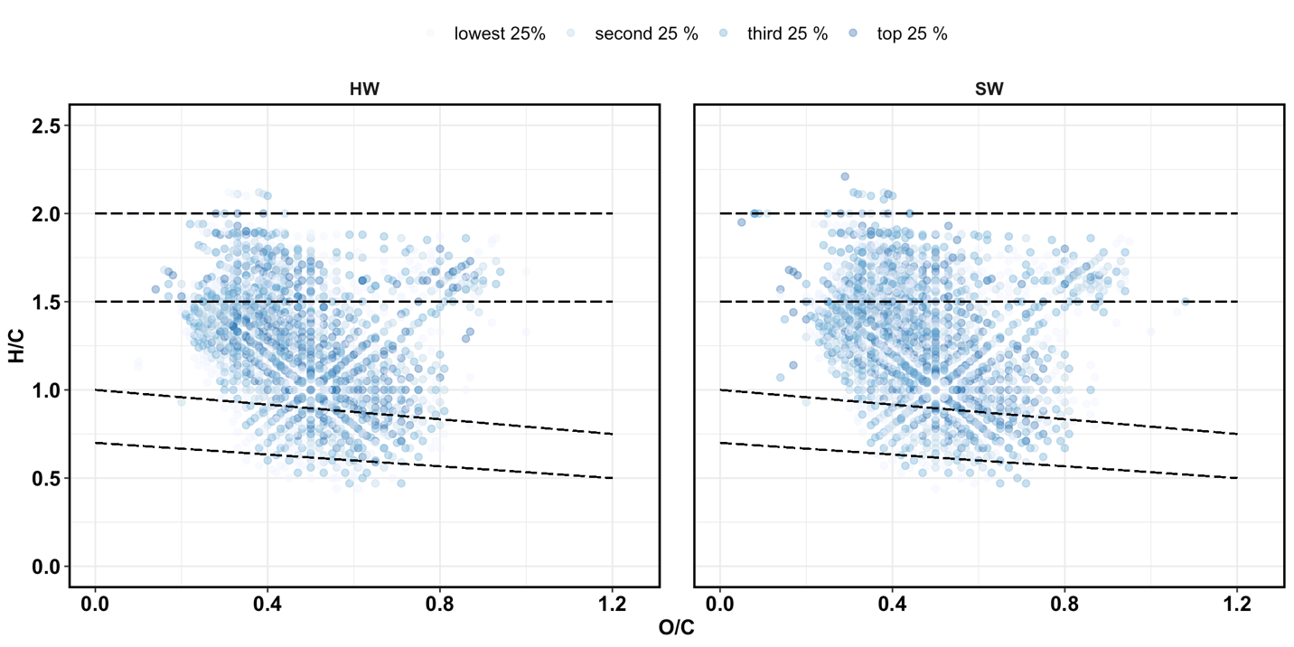**RESULTS AND DISCUSSION**

**Figure 1.** Van Krevelen diagrams for initial (pre-Fenton) SOM molecules in hardwood (HW) and softwood (SW) soils. The intensity of color represents the relative abundance of the molecules.

**Figure 2.** Van Krevelen diagrams for post-Fenton SOM molecules in hardwood (HW) and softwood (SW) soils. The intensity of color represents the relative abundance of the molecules. 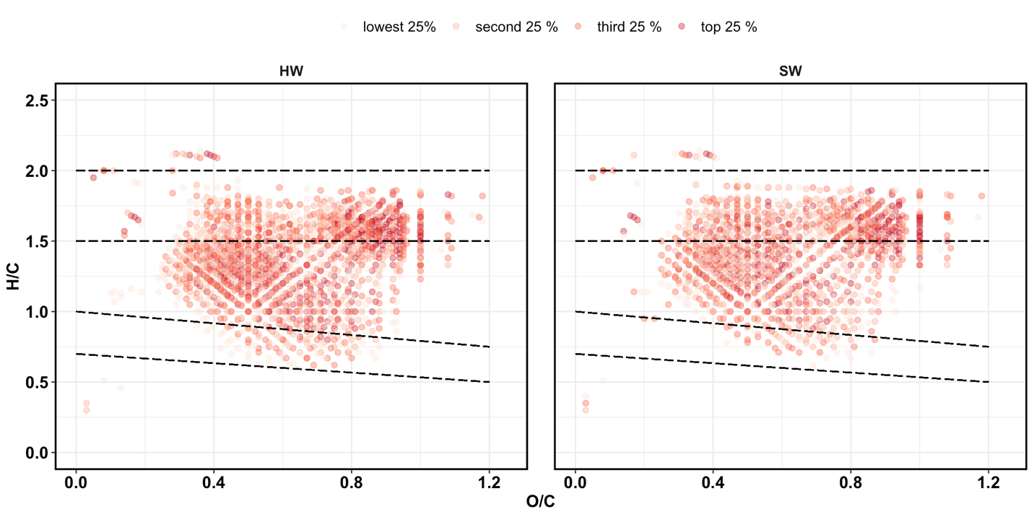

**Table 1.** Relative abundance (percentage) of groups in HW and SW SOM, for initial (pre-Fenton) and post-Fenton soils. Asterisks (*) denote significant differences between initial and post-Fenton samples, and daggers (†) denote significant differences between forest types, at α = 0.05.

|  |  |  |  |  |  |
| --- | --- | --- | --- | --- | --- |
|  | **HW** | |  | **SW** | |
|  | **Initial** | **PostFenton** |  | **Initial** | **PostFenton** |
|  | | | | | |
| DOC concentration, mg/L | 513 ± 12 | 599 ± 9 |  | 656 ± 13 | 640 ± 16 |
| No. of assigned formulas | 1977 | 1924 |  | 1823 | 1707 |
|  | | | | | |
| **Elemental composition** | | | | | |
| C |  |  |  |  |  |
| H |  |  |  |  |  |
| N |  |  |  |  |  |
| O |  |  |  |  |  |
| P |  |  |  |  |  |
| S |  |  |  |  |  |

|  |  |  |  |  |
| --- | --- | --- | --- | --- |
| **Class** | **HW** | | **SW** | |
|  | **Pre-Fenton** | **Post-Fenton** | **Pre-Fenton** | **Post-Fenton** |
| Condensed Ar | 1.48 ± 0.05 | 0.16 ± 0.01 * | 0.99 ± 0.01 | 0.14 ± 0.01 * |
| Aromatic | 8.1 ± 0.27 | 1.85 ± 0.19 * | 7.06 ± 0.13 | 0.86 ± 0.12 * |
| Lignin-like | 60.71 ± 0.55 | 55.36 ± 0.4 * | 58.23 ± 0.24 | 47.52 ± 0.69 * |
| Carbohydrate-like | 6.46 ± 0.13 | 30.04 ± 0.63 * | 5.95 ± 0.11 | 35.09 ± 1.96 * |
| Aliphatic-noN | 15.65 ± 0.63 | 8.43 ± 0.16 * | 21.67 ± 0.32 | 13.6 ± 1 * |
| Aliphatic+N | 7.6 ± 0.25 | 4.17 ± 0.34 * | 6.1 ± 0.06 | 2.78 ± 0.21 * |

Carbs and tannins increased, lignins and proteins decreased post-Fenton. Despite declines, lignin was still 50-55% of total intensity.



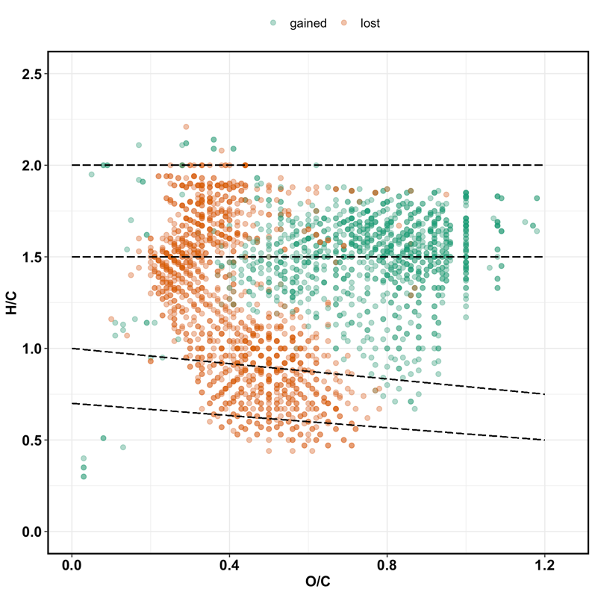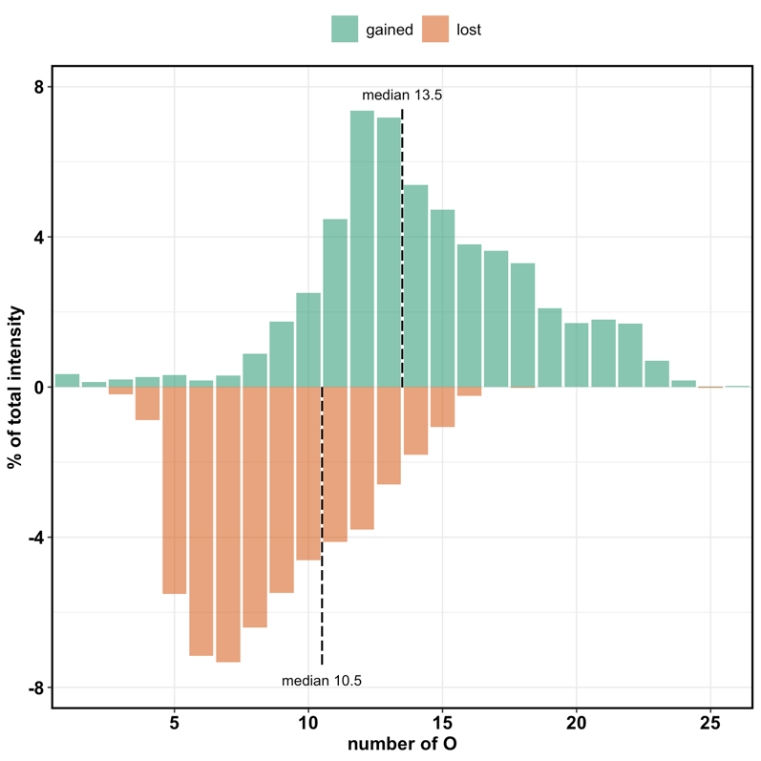

**Figure 3a. VK diagrams of molecules gained or lost followin** **g oxidation via Fenton reaction.**

**Figure 3b. The percentage of total intensity for the lost and newly formed formulas binned by the number of oxygen atoms for the ·OH oxidation treatment.**

**\*\*\* use number of peaks, not intensity**

**Table 2.** Relative abundance (percentage) of groups in pre- and post-Fenton extracts using NMR analysis. The ppm shift range for each group is provided in parentheses.

|  |  |  |  |  |  |
| --- | --- | --- | --- | --- | --- |
| **Functional group  (ppm shift)** | **HW** | |  | **SW** | |
| **Initial** | **Post-Fenton** |  | **Initial** | **Post-Fenton** |
| carbonyl (190-220) | 1.0 | 1.0 |  | 1.1 | 1.2 |
| carboxyl (165-190) | 12.6 | 15.1 |  | 9.4 | 10.9 |
| aromatic (112-165) | 6.2 | 5.3 |  | 5.08 | 3.5 |
| anomeric (90-112) | 11.8 | 13.7 |  | 13 | 14.5 |
| Main carb (58-112) | 52 | 46.6 |  | 58.1 | 53 |
| methoxy (54-58) | 2.9 | 4.0 |  | 2.3 | 2.9 |
| aliphatic (5-54) | 15.1 | 14.9 |  | 11.7 | 16.3 |
| total sum | 101.6 | 100.6 |  | 100.68 | 102.3 |
| total | 100 | 100 |  | 100 | 100 |

1. **Chemical composition of native SOM**

The intensity-weighted Van Krevelen diagrams in **Figure 1** show the distribution of molecules in the native SOM pools as defined by their H/C and O/C ratios. Both HW and SW soils were dominated by lignin-like molecules (**Fig. 1**, **Table 1**), and SOM composition generally did not differ between forest types, with ~ 76 % of peaks (1416) shared by both forest types.

1. **·OH Oxidation Effects on Extract DOC Concentration and Composition.**

The chemical composition of DOC extracts was substantially altered by the Fenton oxidation for both HW and SW soils (**Fig. 2, Table 1**), although the overall DOC concentrations did not differ significantly between pre- and post-Fenton extracts (**Table 1, p = XXXX**). This indicates that our one-hour Fenton treatment resulted in partial oxidation of the DOM components, rather than complete oxidation to CO2.The van Krevelen diagrams also show that that there was a high degree of similarity for the HW and SW extracts, indicating that stand vegetation does not strongly affect DOM chemical composition. We therefore combine both forest types for the remainder of this paper. Overall, molecules with lower O/C ratios, typically considered to be polyphenolic and condensed aromatic were preferentially lost, whereas the newly **detected** molecules generally had H/C > 1.0 and O/C > 0.5, typically considered to be carbohydrate-like **(Fig. 3a)**.

The impact of ·OH oxidation on the DOM chemical composition is also shown by intensities of lost and gained molecules as a function of the O atoms in their formula (**Fig. 3b**). The plot suggests that the ·OH radical reaction was preferentially consuming DOM molecules with ≤ 10 O atoms and the newly detected molecules had ≥ 14 O atoms (median values). This shift to higher O-containing molecules is likely to impact DOM reactivity with soil components, in terms of lability and sorption onto mineral surfaces, which was investigated by reaction with goethite, discussed below.

* 1. **Comparison of FTICR-MS and NMR data.**

We used solid-state 13C NMR to confirm the formation of “new” carbohydrate molecules suggested by FTICR-MS. The relative abundances of functional groups as determined using NMR are reported in **Table 2**., and they provide an interesting contrast to the FTICR-MS results. Carbohydrates accounted for 30-35 % of total abundance across all soils by FTICR-MS analysis (**Table 1**), but nearly 50 % of total abundance by NMR analysis (**Table 2**). Further, carbohydrate abundance showed no change in pre- vs. post-Fenton soils, despite the apparent increase from FTICR-MS analysis (**Table 1**).

These differences may be explained by the processing and analytical techniques used for the two methods. The negative spray ESI technique used for FTICR-MS has been known to be biased in favor of more aromatic molecules like lignin, and aliphatic molecules like carbohydrates are typically underrepresented (Ohno et al. 2016). **Figure 3a** shows that many polyphenolic (lignin-like) peaks were lost due to the Fenton oxidation, allowing for more aliphatic (carbohydrate-like) peaks to be ionized and subsequently detected in the post-Fenton extracts. NMR analysis, on the other hand, does not involve such an ionization process, and therefore is unlikely to show these biases. Thus, we refer to the peaks in **Figure 3a** as “newly detected molecules” and not “newly formed” molecules. NEED A CONCLUDING STATEMENT HERE.

1. **Adsorptive fractionation by Goethite**

Following the method of (Young et al. 2018), we classified the SOM pool into seven categories (“most sorbed” to “most unbound”) to determine potential patterns of selective adsorption. We subtracted the percent abundance of each molecule in the post-Goethite extract from the pre-Goethite extract. The resultant VK diagrams **(Fig. 4)** show clear patterns of sorptive fractionation. Across all soil extracts, low-O, high-H molecules (protein-like) remained largely in solution and did not bind to the goethite, whereas the high-O molecules showed higher tendency to bind to goethite. In the post-Fenton extracts, carbohydrates appeared to sorb more strongly.

The post-Fenton extracts had more detectable high-O and high-H carbohydrate-like molecules **(Fig. 2)**, and this was also reflected in the molecules adsorbed to goethite.

A comparison of pre-and post-Goethite solutions indicated the formation of ~1228 (average of 1194 SW and 1263 HW) new molecules, mostly with O/C ratios < 0.5 and H/C ratios > 1.0 **(Fig. 7)**. These molecules did not differ by Fenton treatment (pre – vs. post-Fenton) or forest type (HW vs. SW).

This is consistent with previous research that has found SOM adsorption was controlled by acidic functional group interactions with iron hydroxides (REF).

In the native SOM pool (pre-Fenton), lignin accounted for 60 % of the sorbed molecules and 40-50 % of the unbound molecules **(Fig. 6)**. This relationship was reversed in the post-Fenton extracts, with lignin contributing to 50-60 % of the unbound molecules and only 30 % of the adsorbed molecules. Carbohydrates, which accounted for 20 % of the unbound molecules in the native SOM pool, in fact contributed to 40 % of the sorbed molecules post-Fenton. Since adsorption onto mineral surfaces typically offers some physical protection to organic molecules, we can assume that the carbohydrates would be less susceptible to mineralization than the lignin molecules. These patterns of adsorption are interesting because aromatic/ polyphenolic compounds typically bind more strongly to mineral surfaces. These molecules make up the first layer of the onion model of SOM sorption.

Studies have described the “onion” model of adsorption, with aromatics forming the first layer, lignins forming the second layer, and simple aliphatics forming the third layer.Since we shook our DOM extracts with goethite for 48 hours, that should theoretically be sufficient time for multiple layers of molecules to sorb onto the mineral surface. (Coward et al. 2019) demonstrated that within two hours, multiple groups of molecules were adsorbed.

These adsorption patterns of pre- vs. post-Fenton extracts may be explained by the oxygen content of the molecules, which has been linked with sorption strength (REF). Consistent with this, our data suggest that molecules with **> 12 O atoms** (median value) were typically sorbed onto goethite, and molecules with **< 7 oxygen atoms** remained generally unbound. **Fig. 8** shows the relative abundance of molecules with varying oxygen contents in the pre-Goethite extracts. We show only the four classes – lignin, carbohydrates, proteins, and tannins – that made up the top 75-80 % of the SOM pool **(Table 1)** and also showed the most siignificant conttibution to the sorbed and unbound fractions post-Goethite **(Fig. 6)**. **Fig. 8** indicates a substantial change in the number of oxygens post-Fenton. The post-Fenton pool showed a greater abundance of carbohydrates and high-O tannins. Low-O lignins and proteins decreased, but intermediate/high-O lignins were unchanged. These changes in oxygen distribution could explain the adsorption patterns. Proteins are primarily < 12 oxygens and therefore not very strongly sorbed to goethite. There seems to be some competitive adsorption of carbs and tannins vs. lignins.

It is unlikely that the shift is merely a reflection of shift in relative abundance of the different groups. Although the abundance of lignin did decline post-Fenton, it still accounted for 50 % of the total SOM pool. This indicates that the O state plays an important role.

For pre-Fenton SOM, medium-O aromatic and polyphenolic molecules were the most sorbed. For post-Fenton SOM, it was mostly high-O molecules, reflecting the changed nature of the SOM pool. for all solutions, the unbound fraction was low-O molecules with high H/C ratios. Lignin-like molecules, which are the most abundant group in both HW and SW SOM, accounted for 60 % of the adsorbed molecules and 40 % of the unbound molecules for the pre-Fenton (native) SOM. This trend was reversed post-Fenton. For the post-Fenton SOM, the contribution of carbohydrates to the adsorbed fraction increased to 40 %.

We see

Thus, we do see that as oxidation progresses and the

**Figure 4.** Adsorptive fractionation following reaction with goethite.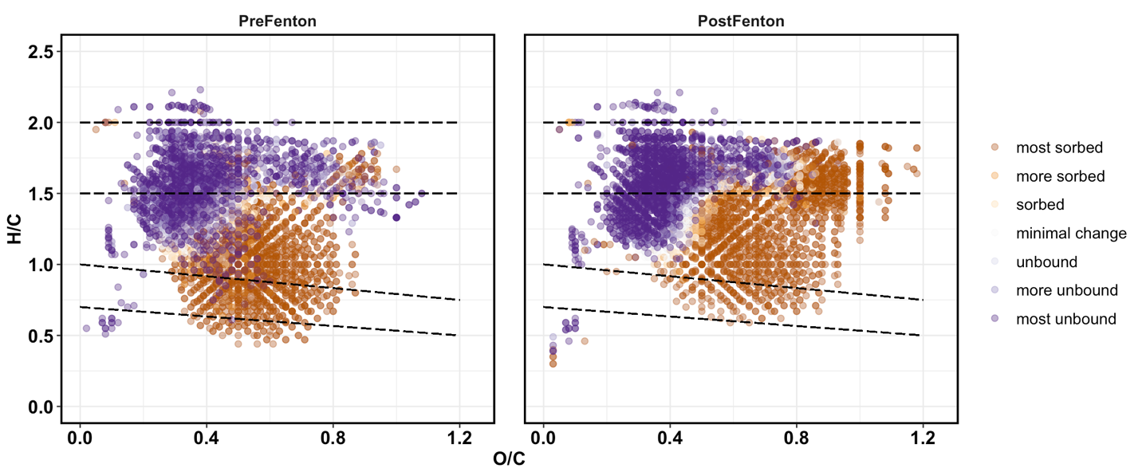

**Figure 6.** 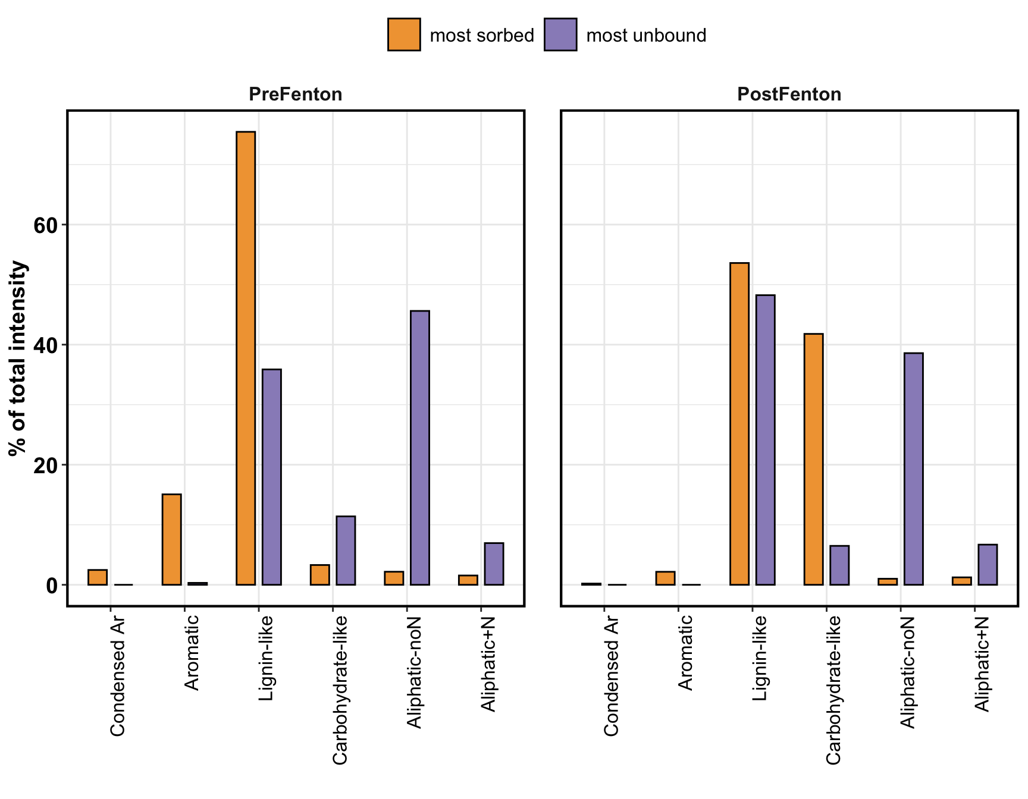

In the native SOM pool, lignin accounted for 60% of the total sorbed compounds. Consistent with previous research.

Post-fenton, carbs were more adsorbed than lignins. **Carbs are more “protected”**?

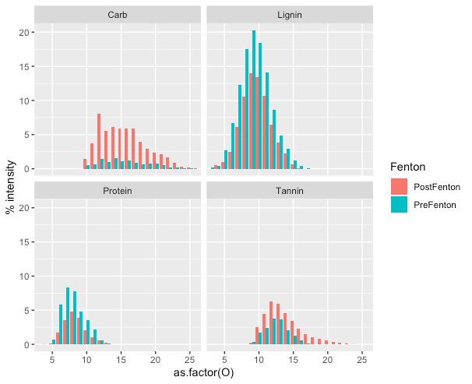

**Figure 8. Relative abundance in pre-Goethite extracts. Only the four most abundant classes have been selected (Table 1). Also the four classes showing the most and/or least adsorption.**

Greater abundance of carbohydrates and high-O tannins post-Fenton. Low-O lignins and proteins decreased, but intermediate/high-O lignins were unchanged. The distribution of oxygens could explain the adsorption patterns. Proteins are primarily < 12 oxygens and therefore unbound. Competitive adsorption of carbs and tannins vs. lignins. Different mechanisms of binding?

Look at the characteristics of the lignins lost and gained. Oxygens, mass, N.